Name: ______________________
Pd: _____ Date: ___________
Descriptive Essay (20 pts)
English 12 Expos Writing

Standard: (W.11-12.4) Produce clear and coherent writing in which the development, organization, and style are appropriate to task, purpose, and audience.
(W.11-12.5) Develop and strengthen writing as needed by planning, revising, editing, rewriting, or trying a new approach, focusing on addressing what is most significant for a specific purpose and audience.

Objective: To paint an image that is VIVID and MOVING in the mind of the reader using sensory detail (5 senses) and specific, concrete, detailed words to describe.
Requirements: Write a 3-5 paragraph essay about an object or place of your choice. This should something that you would enjoy talking about.
Brainstorm Web: Due Friday 1-10
Outline: Monday 1-13
Rough Draft: Tuesday 1-14
Peer Review: Tuesday 1-14
Final Draft Typed: Wednesday 1-15

Step 1: Think of your favorite place, favorite food, or any concrete thing/object you want to write about (a song, a person, a place, etc. ). Using your best sensory details, describe your object or place. Start by gathering facts (see below).
Example: Green Apple
- Green Apple
- Brown Stem
- Small black blemish near the top
- Thin skin
- Juicy
- Crunchy
- Round
- Heavy and solid
- Bitter
- Sweet

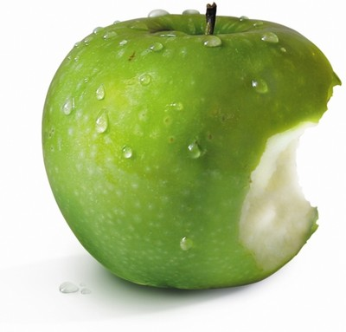
Step 2: Think of how you can add adjectives to create better imagery, nouns to be specific and vivid.
Step 3: Start completing your outline. Think of a grabber or hook in which you can use at the start of your essay to get the reader’s attention. Your thesis statement or central idea can be whatever it is you want to say about your object or place. Your paragraphs will forms as you complete your outline.
CATEGORY | 5 - Awesome | 4 - Average | 3 - Okay |  | Score
Focus or Thesis Statement | The thesis statement names the topic of the essay and outlines the main points to be discussed. | The thesis statement names the topic of the essay. | The thesis statement outlines some or all of the main points to be discussed but does not name the topic.
Concrete Details | Most if not all details are concrete meaning that they can be felt, heard, smelt, or seen. | Some details are concrete. | Not many to none of the details are concrete.
Specific/Vivid Details | Most if not all details are as specific as they can be. | Some details are specific. | Not many or none of the details are specific.
Followed Instructions | Essay is 3-5 paragraphs with at least 4-6 sentences per paragraph. | Essay does not meet all requirements but does meet some of the requirements. | Essay does not meet any of the requirements at all.

